Split the column CITY and separate the code associated

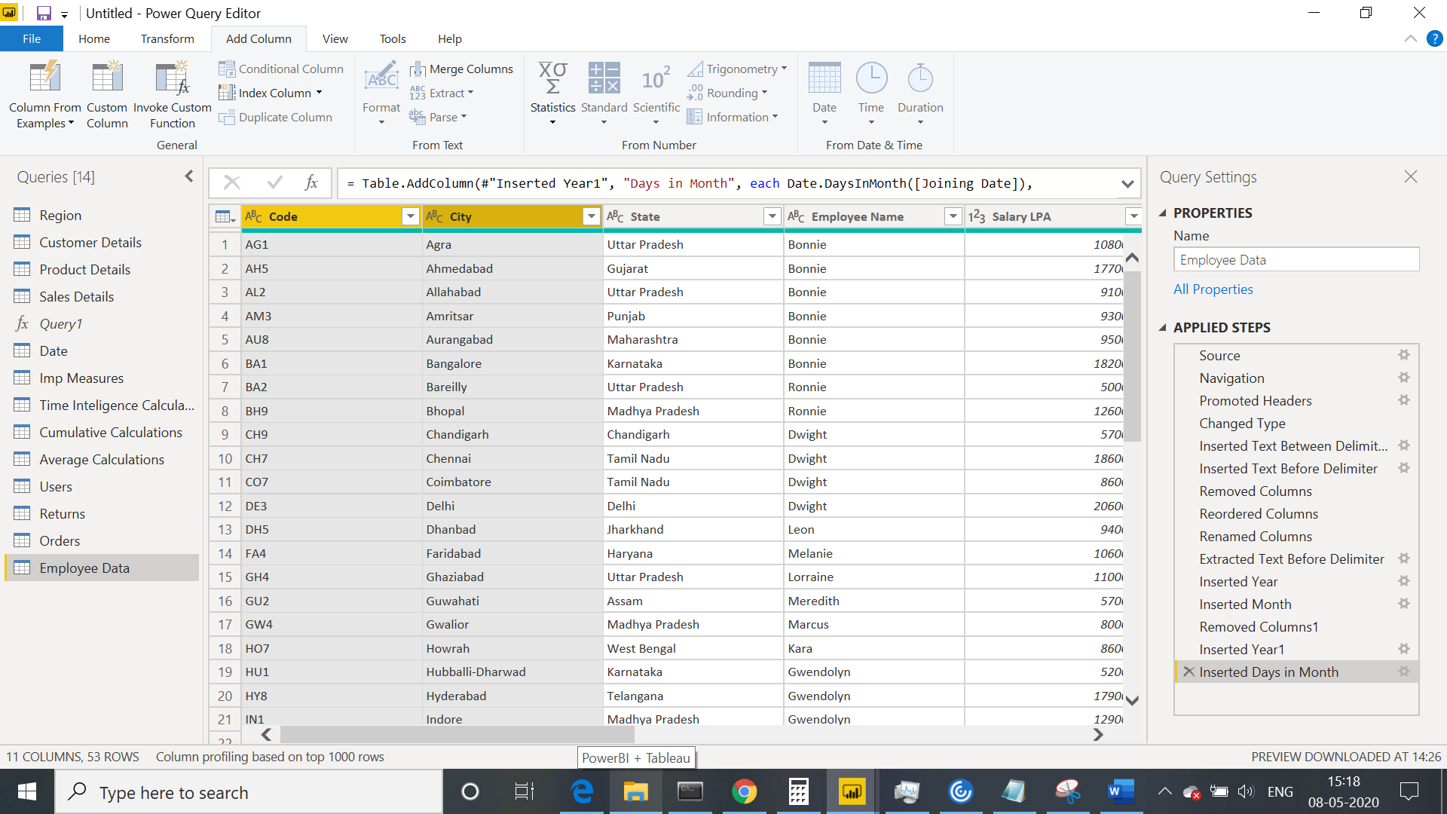

Extract the first name from EMPLOYEE NAME column and transform the column

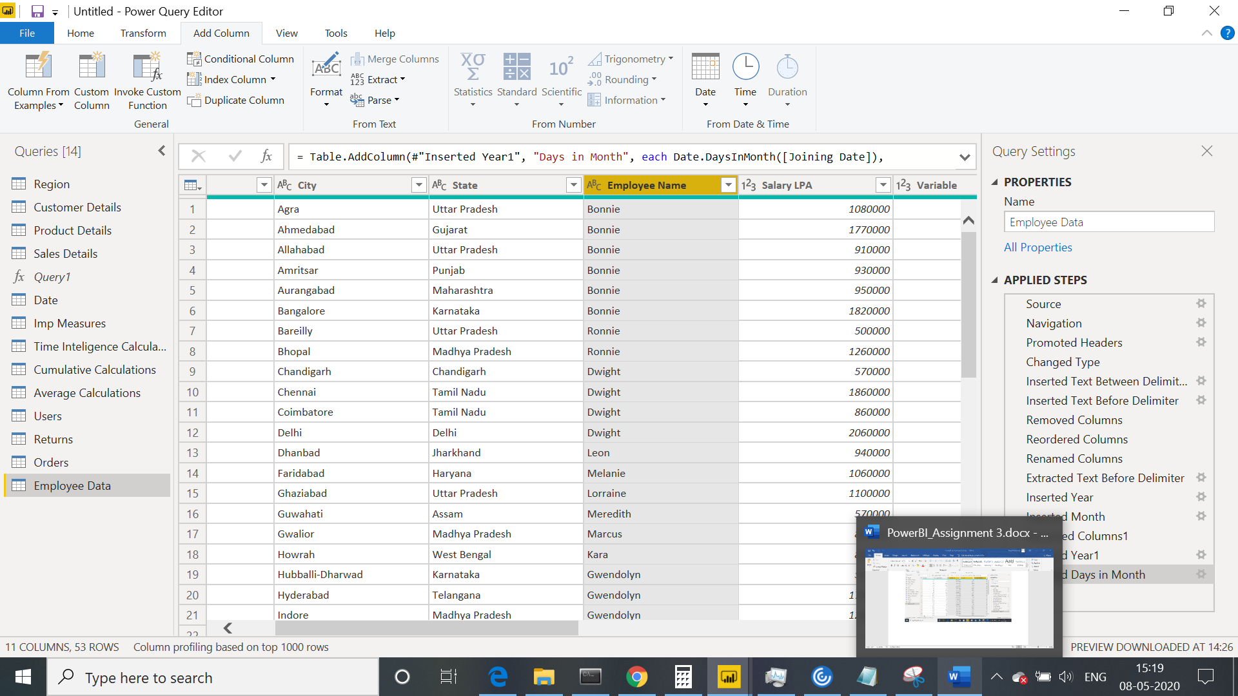

Using the JOINING DATE column extract the Year and no. of days for that month .

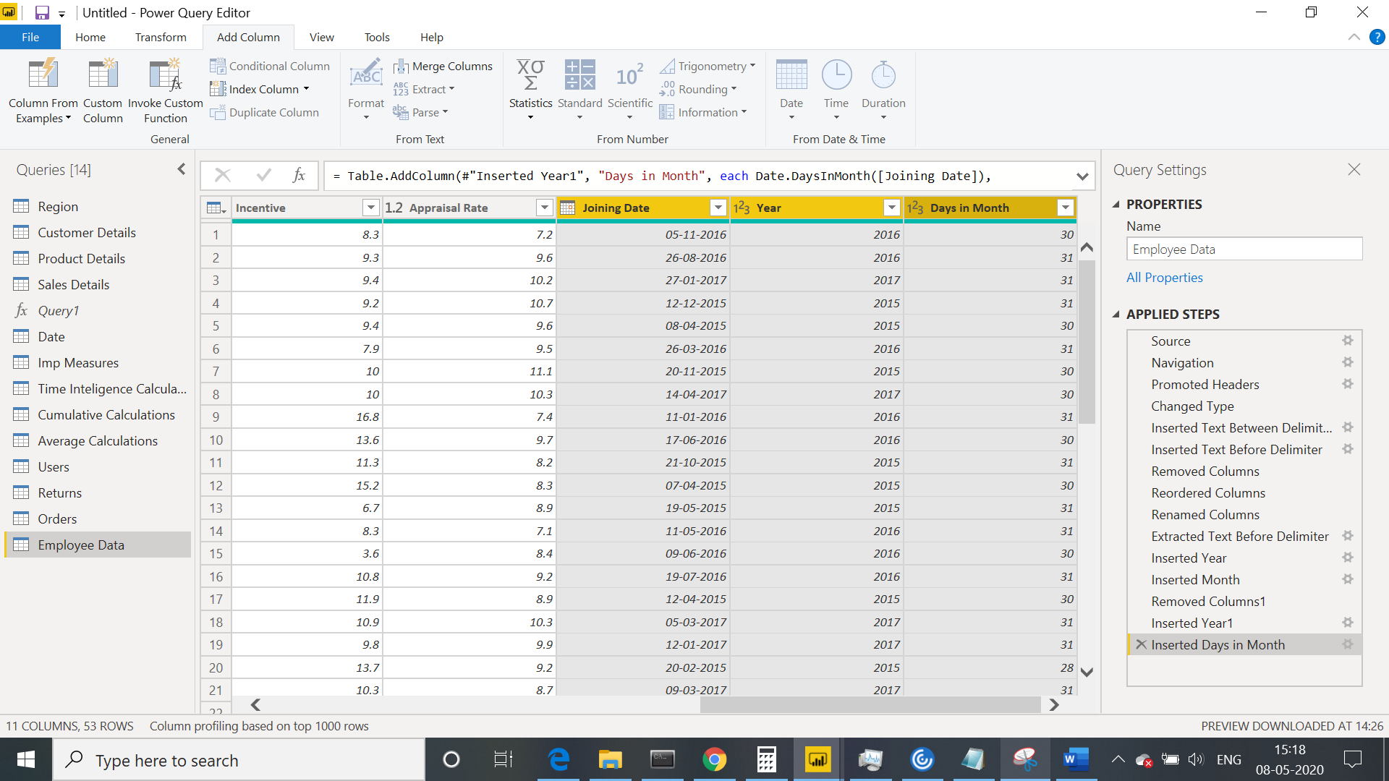

Create a visual of your choice and show the how much salary has been paid to each state and which state has lowest payout.

